Defence Export Controls: Defence and Strategic Goods List – What’s New Webinar – Responses to Questions
23 April 2026
These responses are designed to assist you in understanding Defence Export Control’s regulatory framework. It is not legal advice nor intended to be legal advice and it may therefore include some generalisations about the law. Some provisions of the law referred to have exceptions or prerequisites, not all of which may be described here. Defence does not guarantee the accuracy, currency or completeness of any information contained in this document. Your particular circumstances and activities must be taken into account when determining how the law applies to you. These responses are therefore not a substitute for obtaining your own legal advice and does not imply that other regulatory obligations would not be applicable to certain activities

Question: Will any of these DSGL updates have any impact to the Excluded Technologies List?
Response: No, the DSGL and the Excluded Technologies List are separate legislative instruments and undergo separate review processes.
Question: Do you have an estimate for when these changes will take effect?
Response: The changes are likely to take effect within the next 12-18 months. To be alerted when the amended instrument is registered, we recommend you sign up for the DEC Bulletin mailing list (refer to ‘More Information’ section below) and sign up for alerts through the Federal Register of Legislation website:
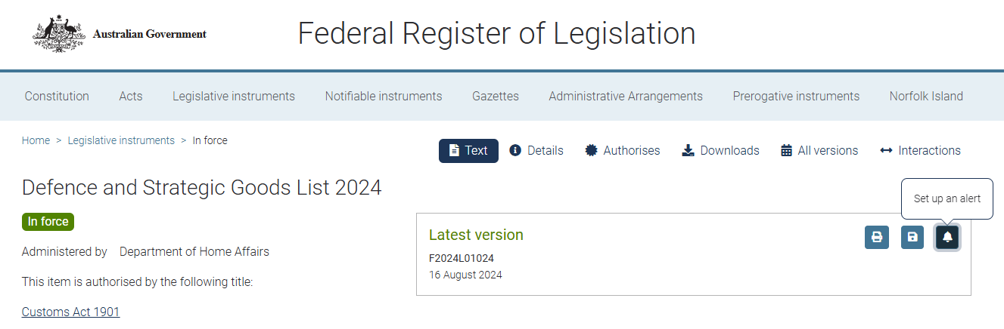

Question: The Explanatory Notes relate to changes from each amendment to the DSGL. Is there any explanatory statement available for the original release of the DSGL text (or for the source international control regimes) that assists with interpretation of the original text where meaning may be considered ambiguous?
Response: The Explanatory Statement provided on the Federal Register of Legislation website details changes made to the preceding version of the DSGL instrument. For supporting information related to the original Defence and Strategic Goods List 1996, see the Federal Register of Legislation.
Information on the regime Common Control Lists can be found on the respective regime websites. Australia Group handbooks are available via the following link: Common Control List Handbooks — The Australia Group.
Note however that there are differences between the regime Common Control Lists and the Defence and Strategic Goods List.
Part 1A- Preliminary of the DSGL functions as the primary contextual and interpretative framework for the DSGL text. It sets out interpretative provisions, including the name, commencement, authority and application of the legislation, a simplified outline of the DSGL, and interpretative guidance through definitions, notes, acronyms and abbreviations.
For specific guidance on the DSGL control status of your goods, technology or software, you can submit a DSGL assessment via the MADE portal.

Question: Can you please share more resources about quantum computation and sensing technologies and materials?
Response: The Defence and Strategic Goods List 2024, currently in force, contains some dual-use controls related to quantum computation and sensing technologies and materials in Categories 3 and 4. The scope of any new or updated controls proposed for the next amendment of the DSGL will be defined by specific text and parameters.
Question: Does it mean that the universities need to apply for a permit if they have these instruments listed in slide 23 for nanoscale semiconductor fabrications and if yes, in which circumstances?
Response: The need to apply for a permit depends on the activity undertaken, the control status of the item, any applicable exemptions or exceptions and is assessed on a case-by-case basis. Please refer to the Defence Export Controls Outreach and Education page for more information on the different permit types and available exemptions/exceptions: Outreach and education | Business & Industry | Defence
If you are unsure whether certain goods or technology meet the control thresholds and specifications once the updated DSGL is registered and in force, you can submit a DSGL assessment to DEC via the MADE portal.

Question: Will this define "specially designed for military end-use"?
Response: “Specially designed for military use” covers items designed or modified for military use. The classification is determined by design intent rather than end-use or marketing. Please refer to the outreach presentation on Technical Assessments for further detail Defence Export Controls: Technical assessments session | Defence.
Question: Given current changes to firearm laws and the standing up of the National Firearms Database, will you be utilising the new NFID portal?
Response: Export permit applications for firearms should be submitted to DEC through the MADE portal as usual.
Question: For a customs broker lodging export declarations, is there a listing of AHECC codes subject to DEC screening so we can proactively support exporters?
Response: The Defence and Strategic Goods List 2024 and AHECC codes serve different regulatory purposes, and do not always overlap. There is no official list of which AHECC codes should trigger a check against the DSGL.
Question: Sometimes, we get a matter where time is of the essence. If timeliness is assessed as valid, how might an application be prioritised (perhaps only for review)?
Response: A request for prioritisation can be made by emailing exportcontrols@defence.gov.au. There is no guarantee your application will be prioritised, however the request can be made.
More information:
Subscribe to the DEC Bulletin by emailing dec.outreach@defence.gov.au
MADE AI: Defence Export Controls MADE AI

