Defence Export Controls: Compliance – What you need to know – Responses to Questions
26 February 2026
These responses are designed to assist you in understanding Defence Export Control’s regulatory framework. It is not legal advice nor intended to be legal advice and it may therefore include some generalisations about the law. Some provisions of the law referred to have exceptions or prerequisites, not all of which may be described here. Defence does not guarantee the accuracy, currency or completeness of any information contained in this document. Your particular circumstances and activities must be taken into account when determining how the law applies to you. These responses are therefore not a substitute for obtaining your own legal advice and does not imply that other regulatory obligations would not be applicable to certain activities

Question: For universities, is there a compliance obligation to do a nationality check on staff who have declared they are using DSGL technology while collaborating with partners listed on the foreign country list or not on the foreign country list?
Response: Similar to all regulated entities, universities (whether or not they are collaborating with partners on DSGL items) should ensure they are complying with the legislative requirements under the Defence Trade Controls Act 2012, Customs Act 1901 and Customs (Prohibited Exports) Regulations 1958. This may include adopting best-practice compliance frameworks to ensure that any export or supply permits are sought, or that the relevant activities are covered by an exemption, exception or not regulated at all (e.g. fall within scope of ‘fundamental research’).
Onshore supplies of DSGL controlled technology from Australia to citizens, permanent residents, body corporates, governments and government authorities from a country on the Foreign Country List (FCL) are generally eligible to rely on the FCL exception unless the technology is on either the Excluded DSGL Goods or Technologies List or Australian Military Sales Program item Determination. This general FCL exception is not available for supplies of DSGL controlled technology from Australia to a place outside Australia.
Question: How long do self-assessments take?
Response: The self-assessment checklist should take no longer than 30 minutes. The self-assessment checklist will be available on our website via the MADE portal.
Question: Is the self-assessment the same as what was used for the pilot - or has it had additional sections or questions included?
Response: Yes, the Tier 1 self-assessment tool is the same as the pilot. There have been some very minor amendments to it and will be rolled out as part of the Compliance Management Program.
Question: For DCRNs that have considerable experience with permit applications, could we please consider not rejecting their applications to say that they can use the AUKUS Exemption? Usually there is a good reason why we choose not to use it, and the exchange does hold up the permit. For new DCRNs, absolutely understand that they might not be aware, but if we choose not to apply the exemption, could we just have our permit application accepted and processed for a permit please?
Response: DEC does not reject any permit application based on the potential availability of using the AUKUS exemption. When the information provided in a permit application indicates that the activity might be eligible to use the AUKUS exemption, DEC will encourage applicants to make full use of their enrolment to access the benefits of the license-free environment (i.e. AUKUS exemption). The AUKUS licence-free environment enables holders of Defence Export Controls Client Registration Numbers (DCRNs) to access specific exemptions under Australian export control laws such that permits are no longer required, provided all legislative criteria are met. If an applicant chooses not to utilise the AUKUS exemptions, DEC will proceed with processing the application through standard procedures.
Upon submission, if you choose not to rely on the AUKUS exemption, please include a note in the Further Information field so this can be taken into account during the assessment of your application.
Question: Do you recommend reapplying for NLR assessments for goods every 12 months, as they have an expiry date of 12 months?
Response: Yes. An Export Controls Assessment (ECA) supports compliance by clarifying whether items meet certain control thresholds on the Defence and Strategic Goods List (DSGL) and, where relevant, if any catch-all prohibitions may apply. This assessment assists persons and organisations in managing risks and ensures adherence to Australia’s export controls legislative framework. You should not rely on a previous ECA if it was issued more than 12 months ago or if any of the circumstances set out in the Advisory Information on the ECA have changed.
Question: The MADE portal was able to put a contact database for consignees and end-users which has now made it easier for users to submit ECAs. Can this be done to a product, make a product database and tag a product if this has been previously not listed in the Defence and Strategic Goods List (DSGL) and do not require a permit? Hopefully this should further streamline and process ECAs quicker?
Response: We cannot do that.
Question: Is there any intention to make the new e-learning module available without having to create an account first? This would make it easier to encourage researchers at universities to use the module.
Response: Not at this stage.
Question: The file size upload limit when submitting applications/assessments is very small, I've had to leave what could be useful out of an application previously, wondering if DEC would consider increasing the limit?
Response: We cannot change the limit as it is not set by DEC.

Question: Previously in the new update to the website we can upload additional supporting documents such as in-principle assessments, why was it removed? Every time I submit an ECA, I have to send an email to export controls with the supporting documents.
Response: The supporting documents option has not been removed and remains available.
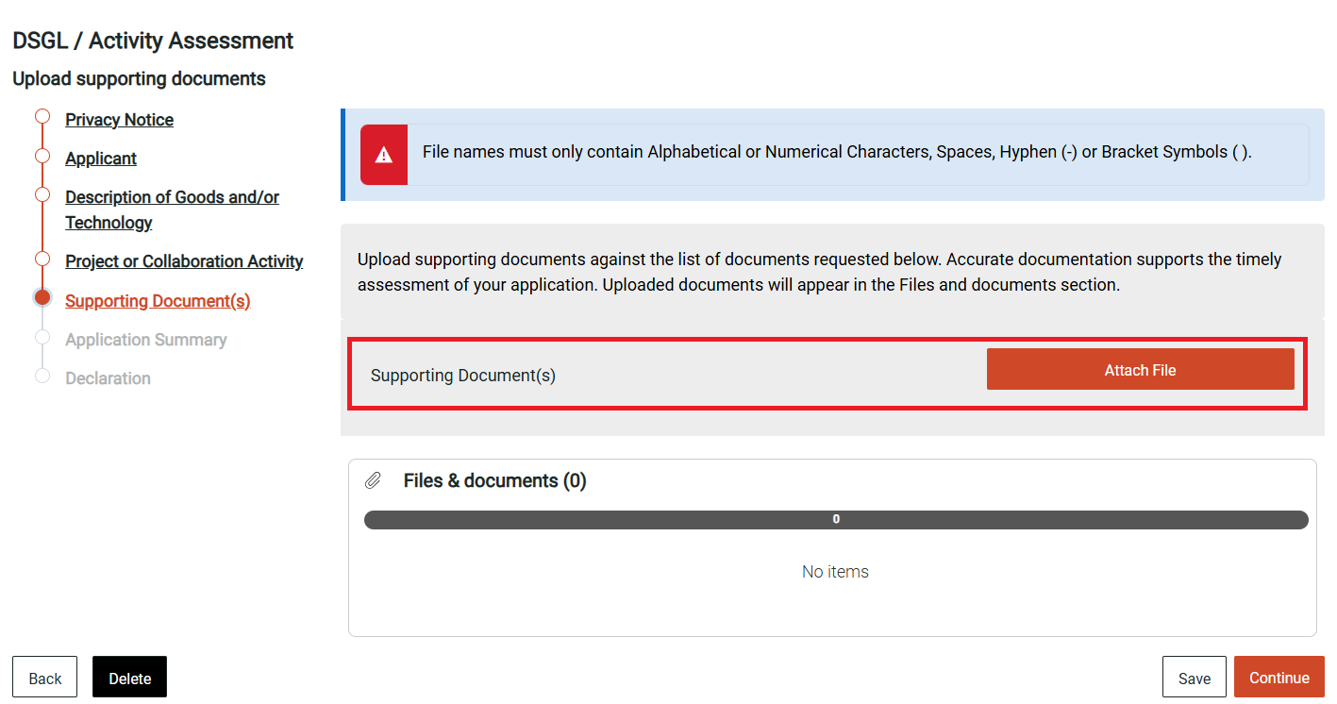
Question: May I please get a copy of this presentation? It is very informative.
Response: This presentation is available on our website with all our previous webinars at Outreach and education | Business & Industry | Defence.
Question: Seems currently there is no option to renew the existing permit. I would like to know the lead time to get an outcome of the new application to replace the current export permit as it is without change.
Response: As the geo-strategic environment is constantly changing we need to assess each and every permit application based on the current or updated information and supporting documents at the time an application is submitted. We do not take a set and forget approach. Defence generally processes non-complex permit applications within 15 days and complex applications within 45 days. More information about applying for a permit is available at My Australian Defence Exports portal | Business & Industry | Defence
Question: Can I add a new end user once I submitted the application without going through submitting another application? This end user is listed in the current permit but some challenge in the defence portal to find this country list to include in the new application.
Response: We assess every end user when determining whether a permit is to be granted. If a permit has not been granted yet, we can amend an application but once a permit has been granted, another application will need to be submitted.
Question: What are the rules and exemptions? [AUKUS?]
Response: Information on the AUKUS licence-free environment, including eligibility criteria is available on DEC’s website.
Australia’s two excluded lists – the Excluded Goods and Technologies List (EGTL) and Australian Military Sales Program (AMSP) item Determination – which specify certain DSGL goods, software and technology that do not qualify for certain exceptions and are not eligible for the AUKUS, or government-to-government, exemptions.
It is important that you are also aware of the other offences and exceptions and exemptions that fall within Australia’s export controls legislative framework. General guidance can be found here within the updated DEC Guidance and Examples document.
Question: is there anything DEC can do to assist AU users of DDTC?
Response: No, DEC does not have any involvement with the US Department of State’s website and portal.
More information:
Subscribe to the DEC Bulletin by emailing dec.outreach@defence.gov.au
MADE AI: Defence Export Controls MADE AI

