Australian Naval Nuclear Power Safety Regulations public consultation – submission guidance

|  |  |
| --- | --- |
| **Your feedback is important to us.**  The Australian Government is committed to transparent and regular community engagement on the nuclear-powered submarine legislative and regulatory framework.  This consultation period represents an opportunity for the community to share views and remain informed on the development of the regulations for | Please complete the form below and submit your feedback on the draft Australian Naval Nuclear Power Safety Regulations before 5.00pm AEST 30 July 2025. |

Australia’s conventionally armed, nuclear-powered submarine enterprise.

**Your name: Your organisation/community**

**association or club:**

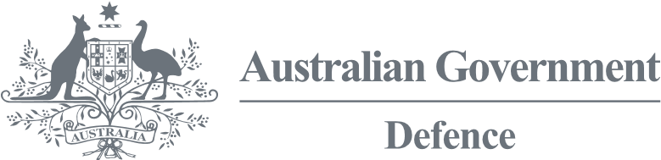**Your contact email:**

**Please complete the following questions below:**

**Q1** | **Do the views you are sharing represent a community group or club?**

**Q2** | **How will the proposed Regulations affect you/your community organisation?**

**Q3** | **Do you have any other comments on the Regulations for consideration?**

**Q4** | **Would you like to stay in touch on the development of the regulations and the Australian Naval Nuclear Power Safety Regulator?**

**Q5** | **How do you like to receive information from the Government?**

**Q6** | **Do you consent to your submission being made public?**

**Q7** | **Is there anything you would like to add?**

**Thank you for taking the time to provide your feedback.**

Please email your response to **annpsr.consulation@defence.gov.au**