Commonwealth of Australia Gazette
No. GN26, 12 July 1989 Special information

COMMONWEALTH OF AUSTRALIA

AUSTRALIAN SERVICE MEDAL REGULATIONS

DECLARATION UNDER REGULATION 3

DETERMNATION UNDER SUBREGULATION 4 (2)
I, WILLIAM GEORGE KAYDEN, Governor-General of the Commonwealth of Australia, on the recommendation of the Minister of State for Defence Science and Personnel, hereby:
- under regulation 3 of the Australian Service Medal Regulations set out in the Schedule to Letters Patent dated 13 September 1988, declare the Commonwealth Military Training Team activity in Uganda during the period that commenced on 18 March 1982 and ended at the end of 24 March 1984 to be a prescribed operation for the purposes of those Regulations; and
- under subregulation 4(2) of those Regulations, determine that the conditions for the award of the Medal in respect of that prescribed operation are:
- the Medal may be awarded to a member of the Australian Army who rendered military service as such a member while posted to or serving with the Australian component of the Commonwealth Military Training Team in Uganda for a period of not less than 90 days during the period referred to in paragraph (a); and
- the Medal shall be awarded to such a member with the clasp “Uganda”.
Dated Thirty First of March 1989
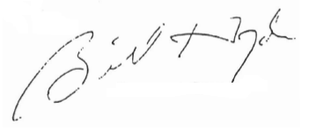
Governor-General
By His Excellency’s Command,
Minister of State for Defence, Science and Personnel

