ASDEFCON Toolbar
and Styles
(Version 1.1)

BatchTools
User Guide
for Word 2016
Overview
The ASDEFCON BatchTools are designed to facilitate the efficient preparation of tenders and contracts by procurement and contracting staff when manipulating several documents at the same time.
BatchTools is designed for use on documents that are temporarily stored in a folder outside of Objective and that are not currently open in word.
BatchTools can be used to;
- Search multiple word documents for terms and clauses simultaneously.
- Change multiple document properties (both defined and custom) simultaneously.
- Prepare multiple documents for publishing by removing personal and potentially commercially sensitive information and document properties simultaneously (e.g. comments, mark-ups, metadata).
- Rename multiple files simultaneously (either partially rename for versions etc. or complete renaming).
- Delete all old DMO styles from multiple documents simultaneously (note; this is a developer tool)
This document guides users through the functionality of the ASDEFCON BatchTools.
Note: This document has been created using the ASDEFCON Styles Set and so, when viewing this document electronically, any text can be selected and examined to determine what style was applied.
Contents
1 Launching ASDEFCON BatchTools and Panels 2
1.1 Launching BatchTools 2
1.2 Functions Panel 3
1.3 Status Panel 4
1.4 Files Panel 4
1.5 Customise 8
2 BatchTool Functions 8
2.1 Term Search 8
2.2 Change Document Properties 12
2.3 Publish 17
2.4 Rename Files 18
2.5 Rename File Version 20
2.6 Delete Styles 25
3 Feedback 26

- Launching ASDEFCON BatchTools and Panels
  - Launching BatchTools
    - Click on the Launch BatchTools button located on the ASDEFCON Toolbar ribbon.

    - This will open the ASDEFCON BatchTools window showing the “Term Search” tab on the “Functions” panel:
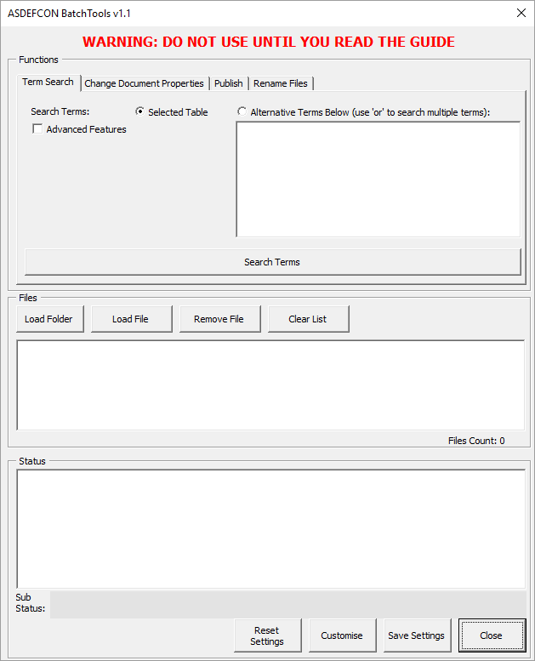
    - The ASDEFCON BatchTools window contains three panels, namely:
      - Functions;
      - Files; and
      - Status.
  - Functions Panel
    - The “Functions” panel by default offers users four functions, each on a separate tab, that form the core of the BatchTools functionality: “Term Search”, “Change Document Properties”, “Publish”, and “Rename Files”. To browse between functions, just click on the tab for the desired function. More explanation is offered for each function in section 1.5.
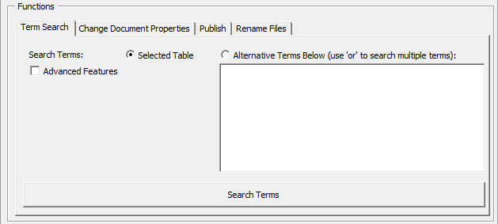
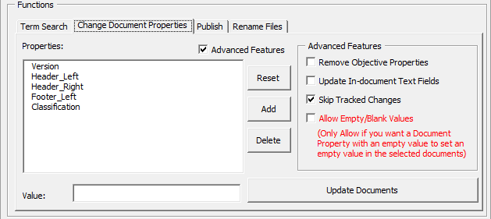
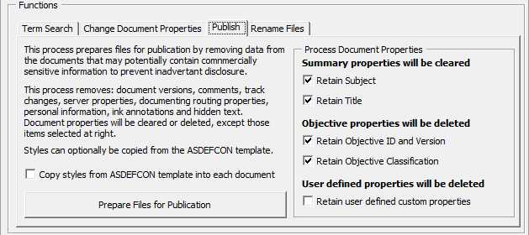
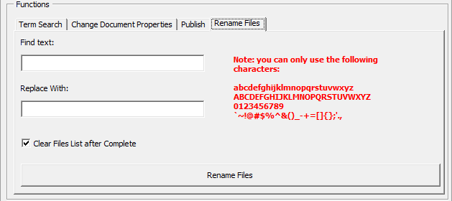
    - In addition to the four core BatchTools functions, there are additional “Rename File Version” and “Delete Styles” functions. These functions are intended for template developers and can be enabled through the BatchTools “Customise” button.
  - Status Panel
    - The “Status” panel displays the status, including progress messages and error reports, when processing files and functions. It is useful to read the output and determine whether a function has successfully completed or requires further action.
  - Files Panel
    - The “Files” panel allows the user to select or remove which files the user wants the BatchTools to manipulate. The user can change between functions at any time by selecting a different function on the “Functions” panel without affecting the files selected.
Note that files can be selected from the file system using a local folder only (eg, H:\ drive). Files in Objective will have to be exported from Objective to a local folder.
    - The following series of images describes the process of adding various files from various folders and removing unwanted files, and finally clearing all the files:
      - Click on the “Load Folder” button. A window will pop-up.
      - Browse to the desired folder you want to add. Note that you will not see any documents in the folder. This is normal. Click OK to load the desired folder.
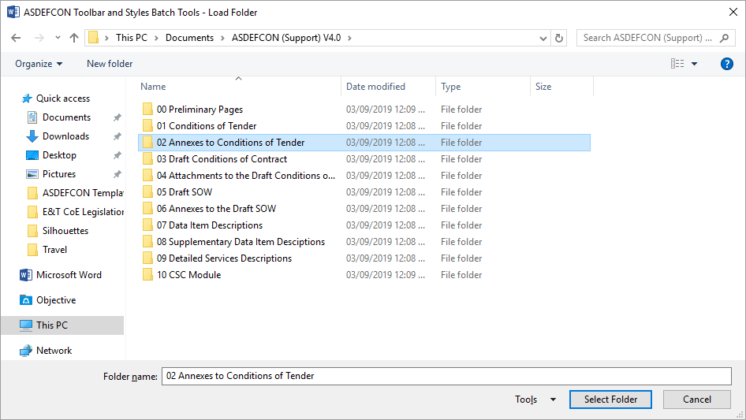
      - The “Files” panel will now display all the Word documents found in the selected folder. The detected documents found will exclusively be those with .doc or .docx extensions.
        - Notice that there is a “Files Count” indicating the number of files currently loaded in BatchTools.
        - Also notice that the “Status” panel has displayed a message indicating the number of files loaded.
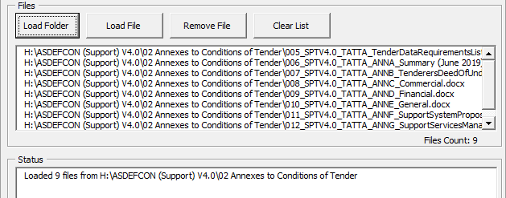
      - To remove one or more files from the list, first select the file(s). For one file, just click the file from the list. For multiple files, hold down the “Ctrl” button on the keyboard and select any additional files.
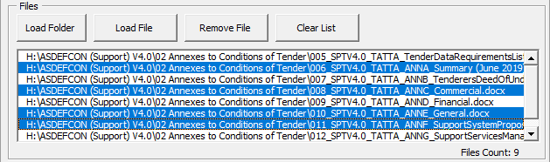
      - Once one or more files have been selected from the list, click on the “Remove File” button to remove the files.
        - Notice that the “Files Count” has now dropped to 5, indicating the total number of files in the list.
        - Also notice that the “Status” panel has displayed a message indicating the number of files removed.
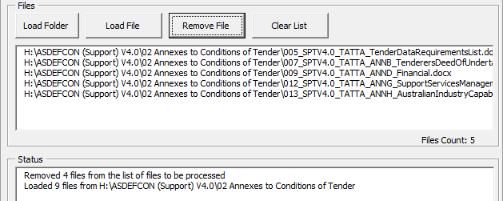
      - To add additional files from another folder, click the “Load File” button. A window will open. Browse to the folder where the desired files are located. Select the desired files. To select multiple files, hold down the “Ctrl” button on the keyboard and select multiple files. Then click on “OK” to load the files.
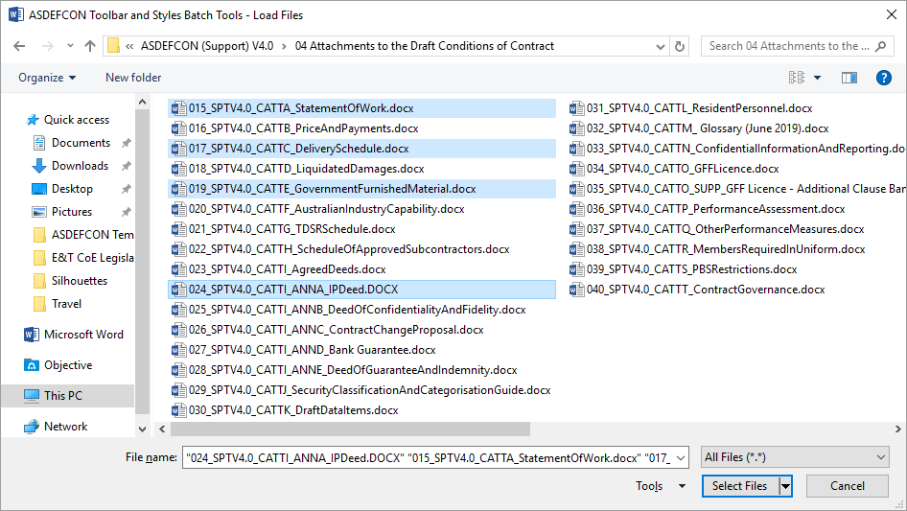
      - Similarly to the “Load Folder” function, the “Files” panel will now display all of the selected Word documents.
        - Notice that there is a “Files Count”, indicating the number of files currently loaded in BatchTools.
        - Also notice that the “Status” panel has displayed a message indicating the number of files loaded.
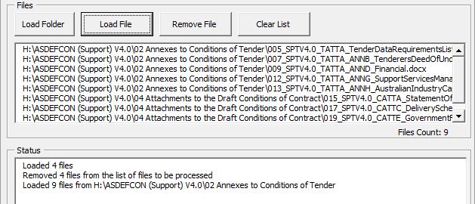
      - Finally, to clear the list, click on the “Clear List” button.
        - Notice that there is a “Files Count”, indicating the number of files currently loaded in BatchTools, which is now 0.
        - Also notice that the “Status” panel has displayed a message indicating that the file list has been cleared.
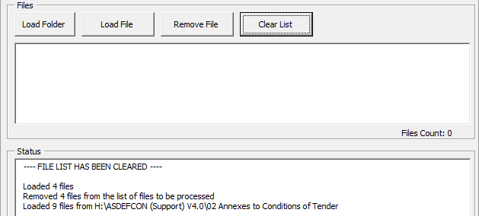
      - Note that, if a user tries to perform any function but has not selected any files, the “Status” panel will display a warning accordingly.
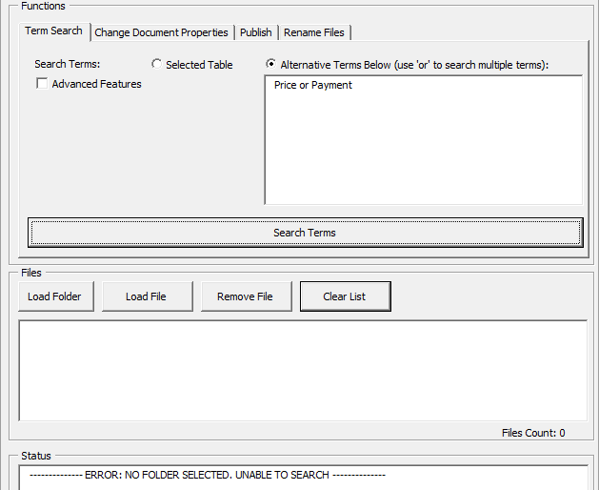
  - Customise
    - The “Customise” button allows a user to enable or disable each panel. This is particularly of use to developers to enable access to the additional “Rename File Version” and “Delete Styles” panels.
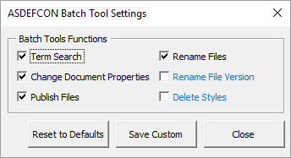
- BatchTool Functions
  - Term Search
    - The “Term Search” function allows the user to search multiple terms throughout multiple documents. The output of the search will be an Excel worksheet listing the number of times each term was found in each document, and the total number of times each term was found in all documents. This can, for example, allow a user to identify whether certain terms found in the Glossary are actually used in the template. “Term Search” can be customised using the “Advanced Features”.
    - The following series of images describes the process for searching certain terms across a number of documents:
      - There are two ways to input search terms for the “Term Search” function:
        - selecting a column of items in an existing document; or
        - typing search terms manually in the “Alternative Terms Below” box.
      - Under the first method, select a column of items in an existing document and then launch the ASDEFCON BatchTools.
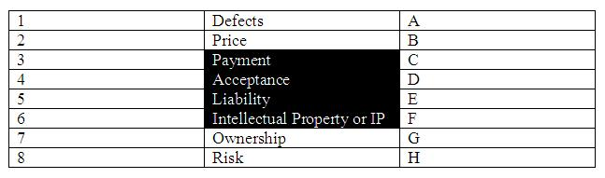
      - When the ASDEFCON BatchTools window opens, the “Selected Table” option will now be enabled and selected. At this time, the user can proceed to search using terms from the selected column items or, alternatively, enter other terms to be searched instead by clicking on the “Alternative Terms Below” option, and then typing the desired search terms in the corresponding textbox. To separate each term, the user needs to enter the word “or” between the words (without the quotation marks), either in the column items (as shown above for “Intellectual Property or IP”) or in the textbox for the “Alternative Terms Below” option.
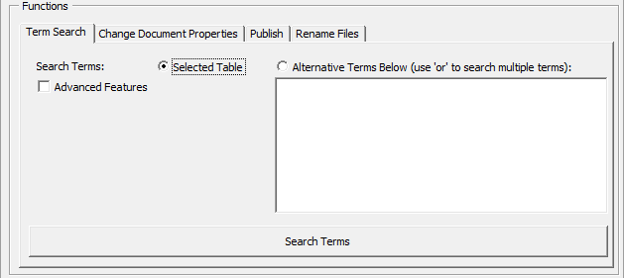
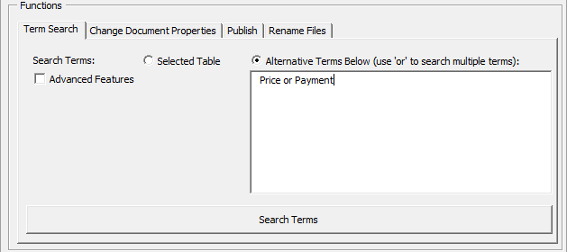
    - Clicking on “Advanced Features” shows options that can be further customised for the search.
      - “Case” – similar to a regular Word search, selecting one of the “Case” options will vary the results of the search.
        - Selecting “Any” will produce results output for each search term when the term is found in any case.
        - Selecting “Match Only” will produce results output for each search term when the term is found in the same case only.
        - Selecting “Both Match and Any” will produce two sets of results output for each search term. This may be useful, for example, when comparing whether a defined term is only used correctly with the starting character capitalised or whether the defined term is incorrectly being used if the result for “Any” is greater than the result for “Match Only”.
      - “Extract Clauses” – ticking this option will extract an excerpt of the clause for each occurrence where the search term was found.
      - “Whole Word” – similar to a regular Word search, ticking “Whole Word” will only search for the input search terms if the exact (whole term) is found. For example, if the search term is “the”, not selecting “Whole Word” would also give results for other terms such as “then”, “these”, “there”, etc.
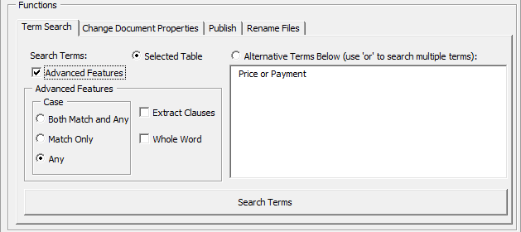
    - Once satisfied with the desired search terms and the search options in the “Advanced Features”, make sure that files are loaded for the search process and click on “Search Terms”.
    - The “Status” panel will display details of the search progress, including:
      - which file is being processed;
      - any errors encountered in processing the file; and
      - overall search progress.
Note that the “Status” panel can occasionally freeze, especially if searching a large document (such as the ASDEFCON Support COC) or a large number of documents. It is recommended that users wait for a few minutes for a progress update rather than attempting to terminate the Word application if this occurs.
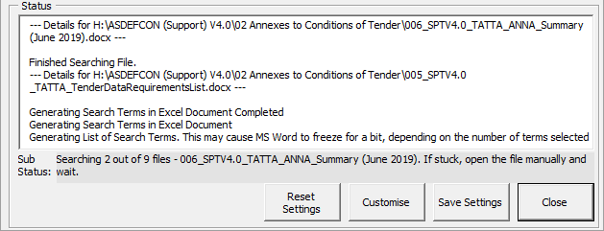
    - Once the search is completed, the “Status” panel will display a message accordingly.
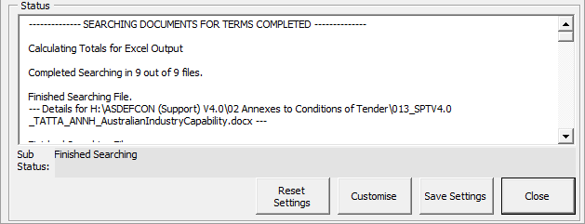
    - The results will then automatically be displayed in an Excel workbook.
    - On the first Excel worksheet titled “Search Results”, the previously selected search options are displayed at the top right corner of the document.
    - The sheet then shows three persistent columns, namely, “Search Terms”, “Match Case” and “Total”, with one additional column for each document selected for the search.
      - The column titled “Search Terms” shows the term that was searched on each row.
      - The column titled “Match Case” shows the “Match Case” option used for performing the search on each row.
      - The column titled “Total” shows the total number of times each search term (row) was found across all selected documents.
      - Each additional column shows the number of times each search term was found in that particular document.
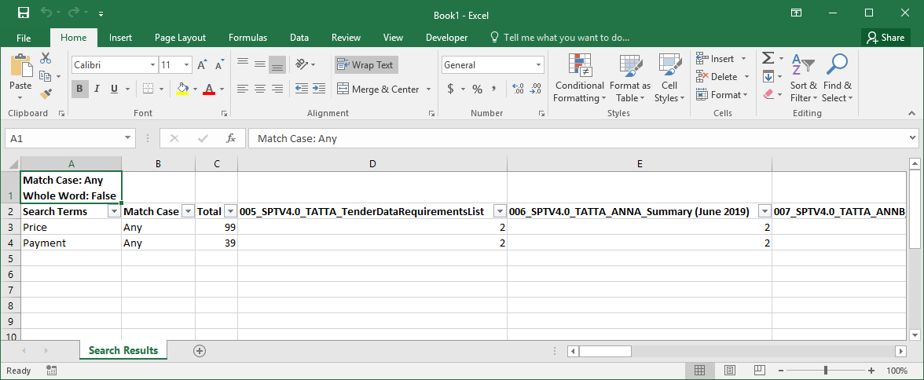
    - If the “Extract Clauses” search option in “Advanced Features” was selected prior to a search, the search results will also generate a second worksheet titled “Extracted Clauses”. This worksheet provides extracts of the clauses where each search term was found from each document selected.
    - It consists of five columns, namely, “Search Term”, “Case”, “Document”, “Reference” and “Clause”.
      - The column titled “Search Term” shows the term that was searched on each row.
      - The column titled “Case” shows the “Match Case” option used for performing the search on each row.
      - The column titled “Document” shows the document in which the search term was found and the column titled “Reference” provides the numbering of the clause from which the search term was extracted.
      - The column titled “Clause” is the extracted clause where the search term was found.
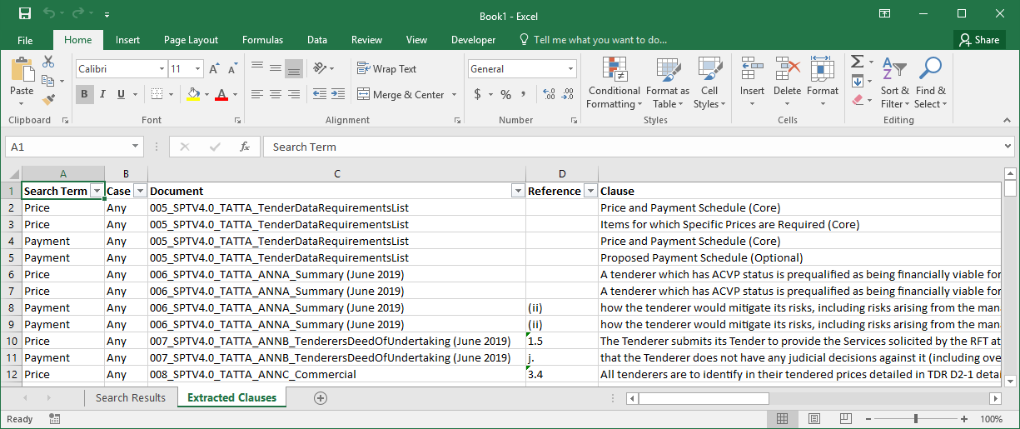
  - Change Document Properties
    - The “Change Document Properties” function allows the user to modify both the default document properties and any custom document properties of multiple documents as a batch. For example, it may be used to remove all properties inserted by Objective or to change the “Title”, “Author” or “Version” of documents. Document properties can be customised using the “Advanced Features” option.
    - The following series of images describes the process of inserting document properties to be changed, editing the new value for the document properties, removing the document properties that should not be changed, changing document properties, updating the fields that represent the document properties in the selected documents and, finally, removing properties inserted by Objective.
    - When the “Change Document Properties” function is selected for the first time, some document properties are listed by default. These are “Author”, “Version”, “Classification”, “Header_Left”, “Header_Right”, and “Footer_Left”.
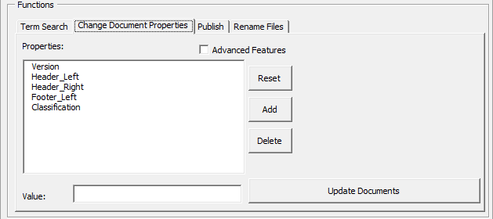
    - Document properties can be removed or added in the list and BatchTools will remember the selected document properties when it is launched again next time.
    - To remove a document property, simply click on it and then click on the “Delete” button.
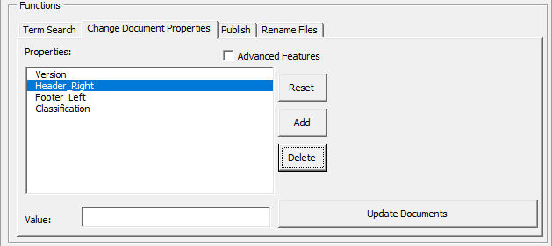
    - Conversely, to insert a document property, click on the “Add” button and type the property’s name in the “New Document Property” window. Then click “OK”. In the following images, the properties “Author” and “Category” have been removed, and the property “Contract_Number” inserted.
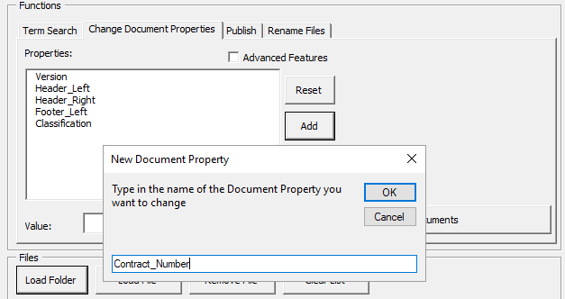

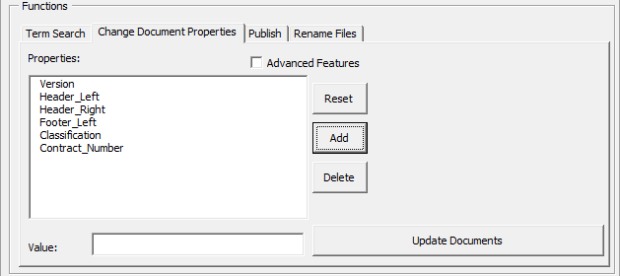
    - To assign a value to each of the corresponding document properties, click on the document property to be changed from the list and type in the desired value in the “Value” textbox. Repeat this process for each document property.
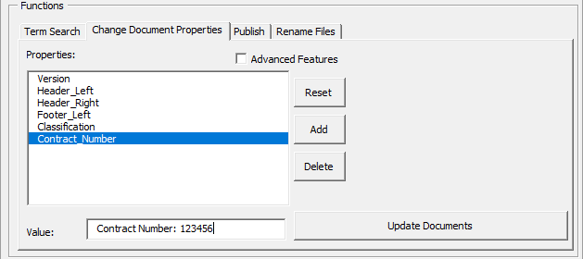
    - Tick the “Advanced Features” checkbox to show the advanced features, which are:
      - “Remove Objective Properties” – ticking this feature will remove all document properties that start with “Objective-”. Note that, every time a Word document is uploaded to Objective, Objective creates custom document properties within it.
      - “Update In-document Text Fields” – ticking this feature will update all in-document text fields. This may be useful to reflect changes in document properties used in the document. For example, the “Header_Left” document property will usually be found on every page of a template in the left side of the header. Selecting the “Update In-document Text Fields” feature will ensure that every instance of the “Header_Left” text field code found in the document will also be updated automatically when the “Header_Left” property is being changed.
      - “Skip Tracked Changes” – ticking this feature will skip tracked changes when updating selected documents, i.e. if the “Update In-document Text Fields” is selected and the selected documents have the “Track Changes” settings activated, BatchTools will temporarily turn off the “Track Changes” settings while updating the in-document text. This may be used to avoid unnecessary tracked changes.
      - “Allow Empty/Blank Values” – ticking this feature will force empty/blank values. Conversely, if this feature is not ticked and the value of a listed document property is left empty or blank, that property will be ignored and not applied to the selected documents. For example, it may be useful to select this feature if the value of “Header_Right” is blank and the intention is to keep the right side of the header for all selected documents blank. Conversely, it may be useful to keep this feature unselected in the event that values for certain document properties have accidentally been left blank and these properties have not been deleted from the list of properties.
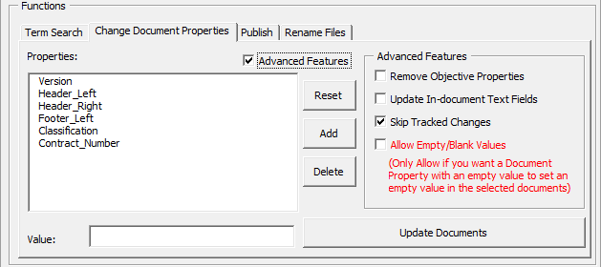
    - Once satisfied with the desired document properties, their values and the options in “Advanced Features”, make sure that the set of files to be processed are loaded in the “Files” panel, and click on “Update Documents”.
    - A message will pop-up to confirm the selected value for each of the document properties and prompt the user to confirm to proceed and update the documents.
    - In the example below, the values for “Footer_Left”, “Header_Right”, “Header_Left”, “Classification”, “Version” and “Title” have been set to blank, and the corresponding document properties in the selected documents will clear the values for these properties. This is only possible when “Allow Empty/Blank Values” is ticked in the “Advanced Features”.
    - Double check and make sure you are satisfied with the desired options and then click “Yes” to proceed.
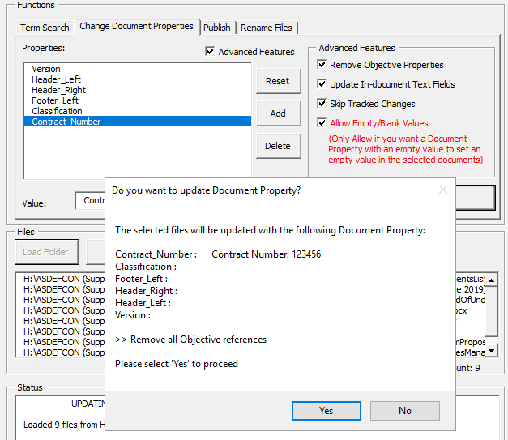
    - The “Status” panel will display details of the process for updating the document properties, including:
      - which file is being processed;
      - any errors encountered in processing the file; and
      - overall progress.
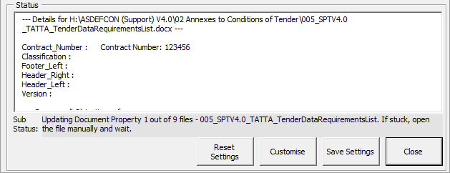
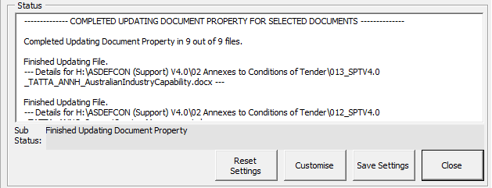
Note that the “Status” panel can occasionally freeze, especially if updating in-document text fields for a bulky document (such as the ASDEFCON Support COC) or a large number of documents. It is recommended to wait for a few minutes for a progress update rather than attempting to terminate the Word application if this occurs.
  - Publish
    - The “Publish” panel enables a user to apply the “Publish” function to a set of files to remove identifying information, tracked changes and hidden text from the document before release.
    - With no boxes checked the “Publish” function will aggressively remove all of the document properties except for the standard ASDEFCON properties. If you need to retain any properties, particularly if you have defined your own custom properties, then you need to select the appropriate box to retain them.
    - The function also provides an option to copy the styles from the ASDEFCON Styles template into each document, so that formatting is available if the template becomes detached.
  - Rename Files
    - The “Rename Files” function allows the user to amend a common part in the name of multiple documents as a batch. For example, it may be used to replace the “_ASDEFCON_SPTS_V1_0_” found in the Support Short template document names to “ - Contract 123456 - ”. In doing so, the file “009_ASDEFCON_SPTS_V1_0_COC_ATTB [Price Schedule].DOC” would be renamed to “009 - Contract 123456 - COC_ATTB [Price Schedule].DOC”.
    - The following series of images describes the process of amending a common part found in the documents’ file name to a different text.
    - When “Rename Files” is selected, the panel displays input for “Find Text”, “Replace With” and an option to “Clear Files List after Complete”. The “Clear Files List after Complete” option is ticked by default because once the names of the files are changed the old file names that will still be in the “Files” panel are no longer valid.
    - Input the required text in the “Find Text” and “Replace With” fields.
      - “Find Text” – this is the common text that BatchTools will search for in the files’ names. If it is found, the text will then be replaced with the desired text in the “Replace With” field.
      - “Replace With” – this is the desired new text that BatchTools will use to replace the common text.
    - Once satisfied with the “Find Text”, and “Replace With”, make sure that files are loaded and click on “Rename Files”.
    - A message will pop-up to confirm the selected options and prompt the user to confirm to proceed and update the selected files.
    - Double check and make sure you are satisfied with the desired options and then click “Yes” to proceed.
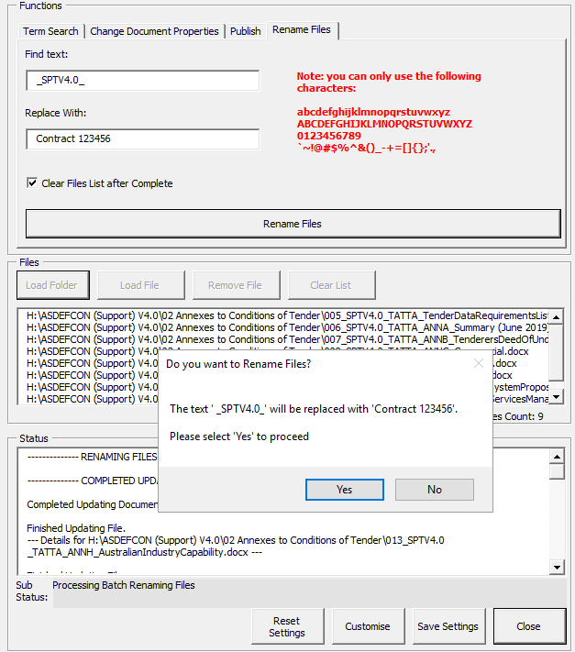
    - The “Status” panel will display details of the process for updating the files, including:
      - which file is being processed;
      - any errors encountered in processing the file; and
      - overall progress.
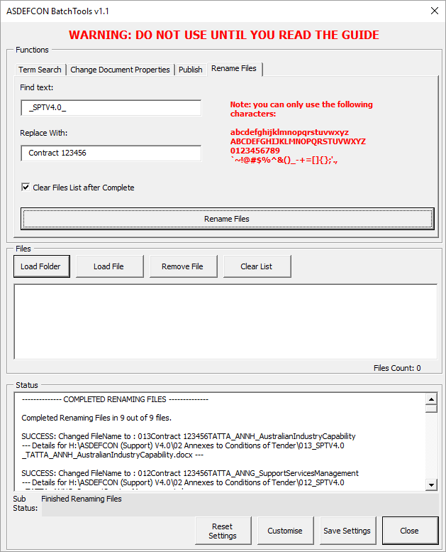
  - Rename File Version
    - The “Rename File Version” function allows the user to amend the version found in the respective file name of multiple documents as a batch. For example, it may be used to change all documents that are named in the format “XXX_CMV2_v4.0_DETAILS.doc” to “XXX_CMV2_v4.1_DETAILS.doc”. In addition to amending file names, the “Rename File Version” function may also be used to change the “Version” document property of the selected documents. This function is available under “Advanced Features”.
    - The following series of images describes the process of amending the version found in the respective file name of selected documents and their corresponding “Version” document property.
    - When “Rename File Version” is selected for the first time, the panel shows input for “Expected Version”, “New Version” and an option for “Advanced Features”.
    - Type in the “Expected Version” and the “New Version”.
      - “Expected Version” – this is what the BatchTools will look for and replace in the name of the selected files (and the document properties if the “Advanced Features” option is selected). Note the warning next to it: If the “Expected Version” box is left empty, BatchTools will force the “New Version” for all selected documents regardless of what version they hold or whether they hold any version at all.
      - “New Version” – this is the new version that will be inserted in the selected files’ names (and the document properties if the “Advanced Features” option is selected).
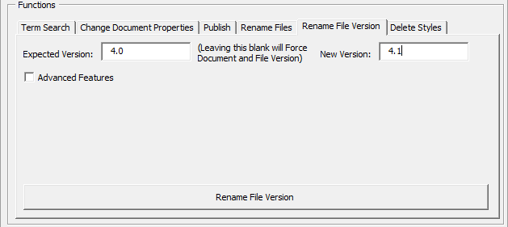
    - Tick “Advanced Features” to show the “Advanced Features” options as follows:
      - “Force File Version” – ticking this feature will make BatchTools force the “New Version” for all selected documents regardless of what version they hold or whether they hold any version at all, i.e. the value inserted for “Expected Version” will be completely ignored.
      - “Clear Files List after Complete” – ticking this feature will clear the list of selected files. This is selected by default because the names of the files in the list will be different after the process of amending the file version in the files’ names.
      - “Update Reference/Document Property” – ticking this will also update the “Version” document property for the selected files. This works similarly to the “Change Document Properties” function, but only changes the value in the “Change Document Properties” panel.
      - “Update In-text Fields” – ticking this feature will update all in-document text fields if the “Update Reference/Document Property” option is selected. This may be useful to reflect changes in version of the file name as well as the “Version” in the document properties for selected files.
      - “Skip Tracked Changes” – ticking this feature will skip tracked changes when updating each selected document, i.e. if the “Update Reference/Document Property” and “Update In-text Fields” options are selected, and the selected files have the “Track Changes” settings activated, BatchTools will temporarily turn off the “Track Changes” settings while updating the in-document text. This may be used to avoid unnecessary tracked changes.
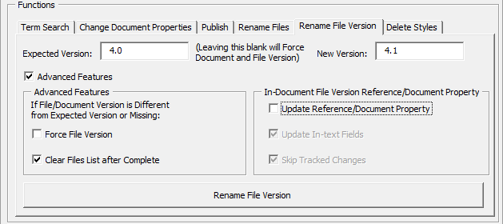
    - Once satisfied with the desired “New Version” and the options under “Advanced Features”, make sure that the set of files to be processed are loaded in the “Files” panel, and click on “Rename File Version”.
    - A message will pop-up to confirm the selected options and prompt the user to confirm to proceed and update the selected files.
    - The value “True” for an option means that the option has been selected, whereas the value “False” for an option means that the option has not been selected. The value “N/A” for an option means that the option is not applicable.
    - Double check and make sure you are satisfied with the desired options and then click “Yes” to proceed.
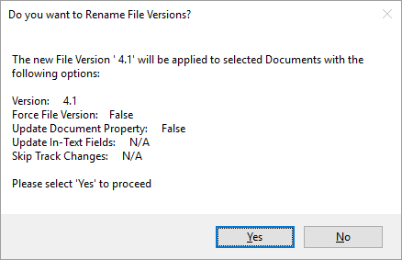
    - The “Status” panel will display details of the process for updating the files including:
      - which file is being processed;
      - any errors encountered in processing the file; and
      - overall progress.
    - In the first example below, although the process completed successfully, no amendments were made to most of the file names because the files’ versions were different from the “Expected Version” and “Force File Version” was not selected.
    - Moreover, the “Version” document property was not amended since the “Update Reference/Document Property” option was not selected.
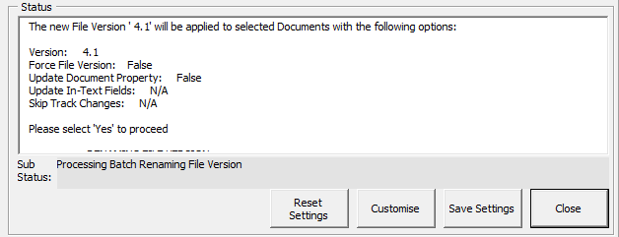
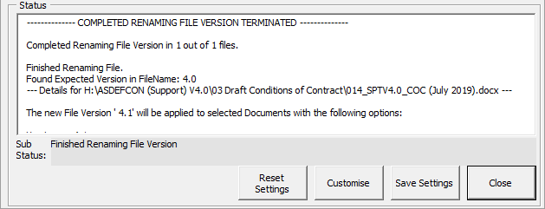
    - In the second example below, the “Force File Version” and the “Update Reference/Document Property” options have been selected.
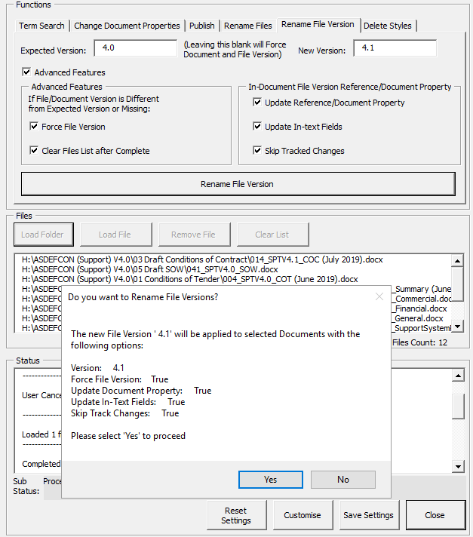
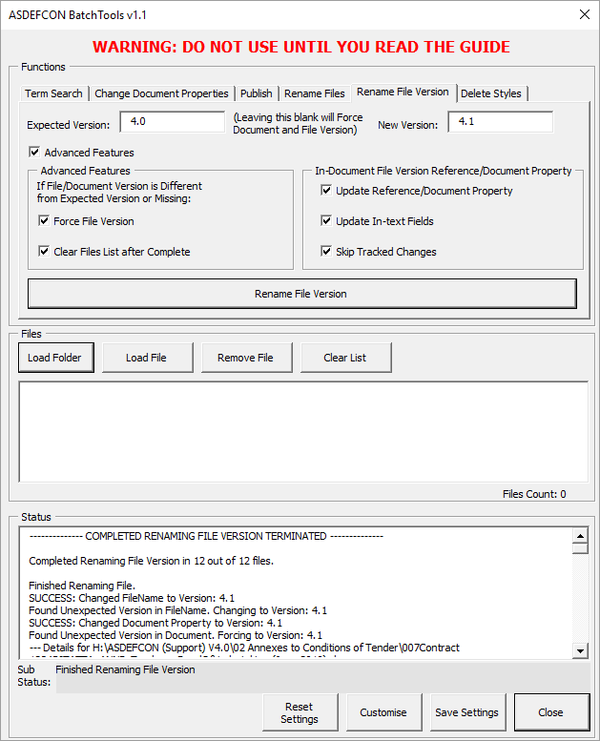
  - Delete Styles
    - The “Delete Styles” function is intended for template developer use and will remove all styles that are not included in the ASDEFCON Styles from the documents that are loaded in the “Files” panel.
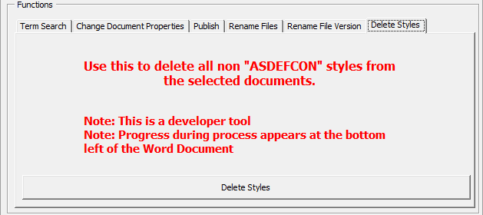
- Feedback
For feedback or inquiries about the ASDEFCON Toolbar and Styles, including the ASDEFCON BatchTools, please contact the ASDEFCON and Contracting Initiatives Help Desk by e-mail at procurement.ASDEFCON@defence.gov.au.

